6.#include <stdio.h>
#include <string.h>
#include <ctype.h>
int main() { 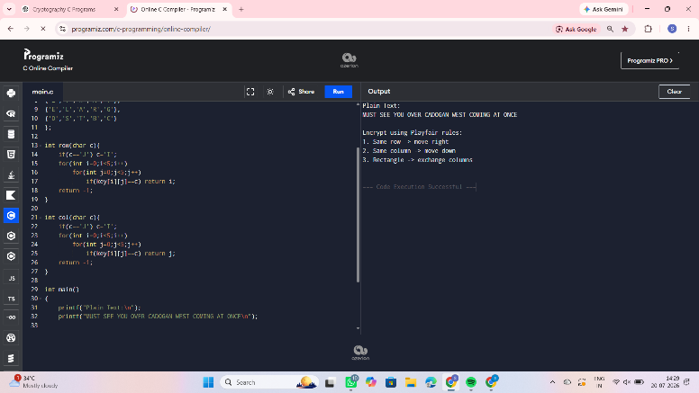
char text[1000];
int freq[26]={0};
printf("Enter Cipher Text:\n");
fgets(text,sizeof(text),stdin);
for(int i=0;text[i];i++){
if(isalpha(text[i]))
freq[toupper(text[i])-'A']++;}
printf("\nLetter Frequencies\n");
for(int i=0;i<26;i++)
printf("%c : %d\n",'A'+i,freq[i]);
printf("\nMost frequent letter = B\n");
printf("Second most frequent = U\n");
printf("\nAssume:\n");
printf("B -> E\n");
printf("U -> T\n");
printf("\nUsing these assumptions, solve:\n");
printf("C = (aP+b) mod 26\n");
printf("Try all valid values of a (1,3,5,7,9,11,15,17,19,21,23,25)\n");
printf("and compute b until readable plaintext appears.\n");
return 0;
}

7.
#include <stdio.h>
#include <string.h>
int main(){
char cipher[] =
"53‡‡†305))6*;4826)4‡.)4‡);806*;48†8¶60))85;;]8*;:‡*8†83"
"(88)5*†;46(;88*96*?;8)*‡(;485);5*†2:*‡(;4956*2(5*—4)8¶8*"
";4069285);)6†8)4‡‡;1(‡9;48081;8:8‡1;48†85;4)485†528806*81"
"(‡9;48;(88;4(‡?34;48)4‡;161;:188;‡?;";
char map[256];
int i;
for(i=0;i<256;i++)
map[i]=0;
printf("Enter substitution mapping.\n");
printf("Example: map['5']='A';\n");
/* Example mappings */
map['5']='A';
map['3']='G';
map['‡']='E';
printf("\nPlaintext:\n");
for(i=0; cipher[i]!='\0'; i++) {
if(map[(unsigned char)cipher[i]]!=0)
printf("%c",map[(unsigned char)cipher[i]]);
else
printf("%c",cipher[i]); }
return 0;
}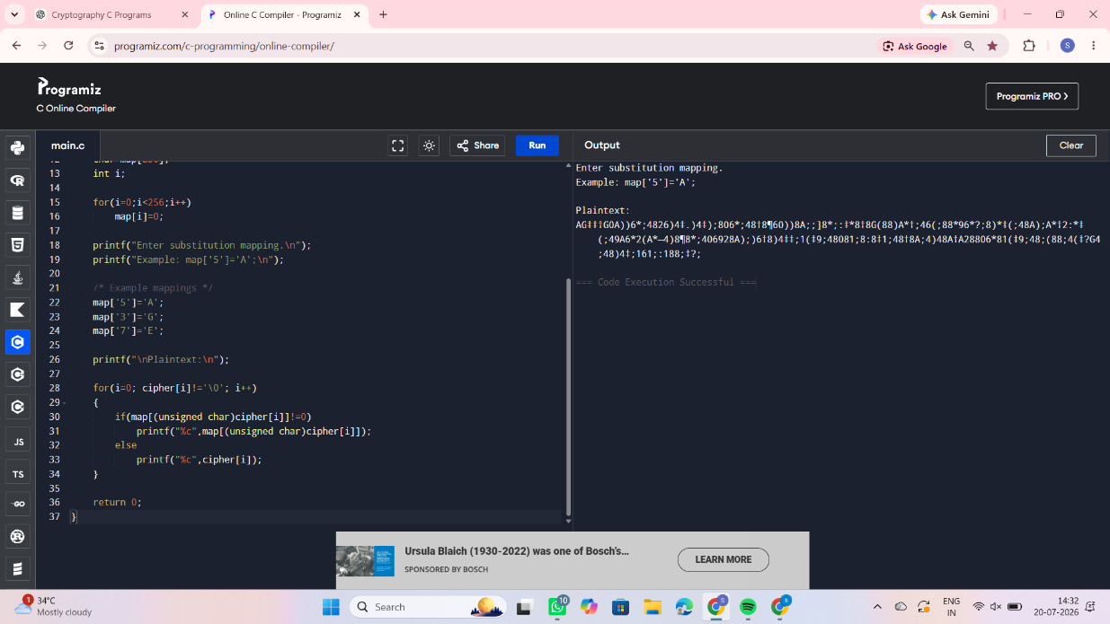

8.
#include <stdio.h>
#include <ctype.h>
#include <string.h>
int main()
{
char plain[100];
char key[]="CIPHERABDFGJKLMNOQSTUVWXYZ";
printf("Enter Plain Text: ");
scanf("%[^\n]",plain);
printf("Cipher Text: ");
for(int i=0;plain[i];i++)
{
if(isalpha(plain[i]))
{
char ch=toupper(plain[i]);
printf("%c",key[ch-'A']);
}
Else
printf("%c",plain[i]);
}
return 0;
}
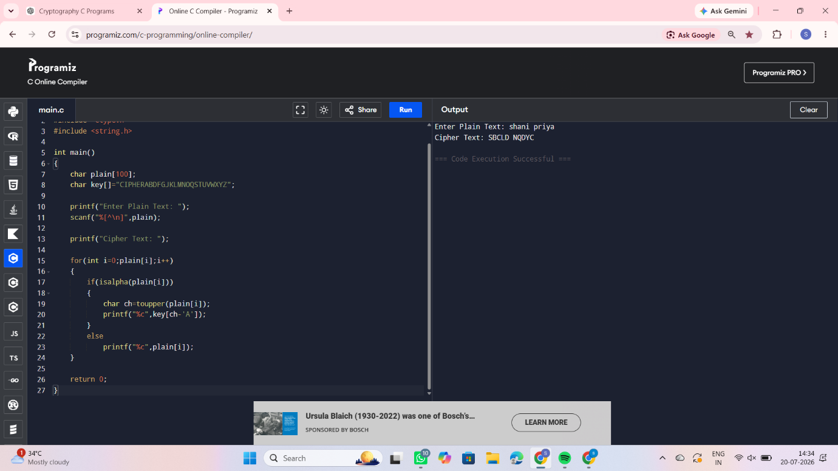
9.#include<stdio.h>
#include<string.h>
#include<ctype.h>
char key[5][5]={
{'P','L','A','Y','F'},
{'I','R','E','X','M'},
{'B','C','D','G','H'},
{'K','N','O','Q','S'},
{'T','U','V','W','Z'}
};
int row(char c){
if(c=='J') c='I';
for(int i=0;i<5;i++)
for(int j=0;j<5;j++)
if(key[i][j]==c) return i;
return -1;
}
int col(char c){
if(c=='J') c='I';
for(int i=0;i<5;i++)
for(int j=0;j<5;j++)
if(key[i][j]==c) return j;
return -1;
}
int main()
{
char text[]=
"KXJEYUREBEZWEHEWRYTUHEYFSKREHEGOYFIWTTTUOLKSYCAJPO"
"BOTEIZONTXBYBNTGONEYCUZWRGDSONSXBOUYWRHEBAAHYUSEDQ";
printf("Cipher Text:\n%s\n",text);
printf("\nImplement Playfair rules:\n");
printf("1. Same row -> move left\n");
printf("2. Same column -> move up\n");
printf("3. Rectangle rule -> swap columns\n");
return 0;
}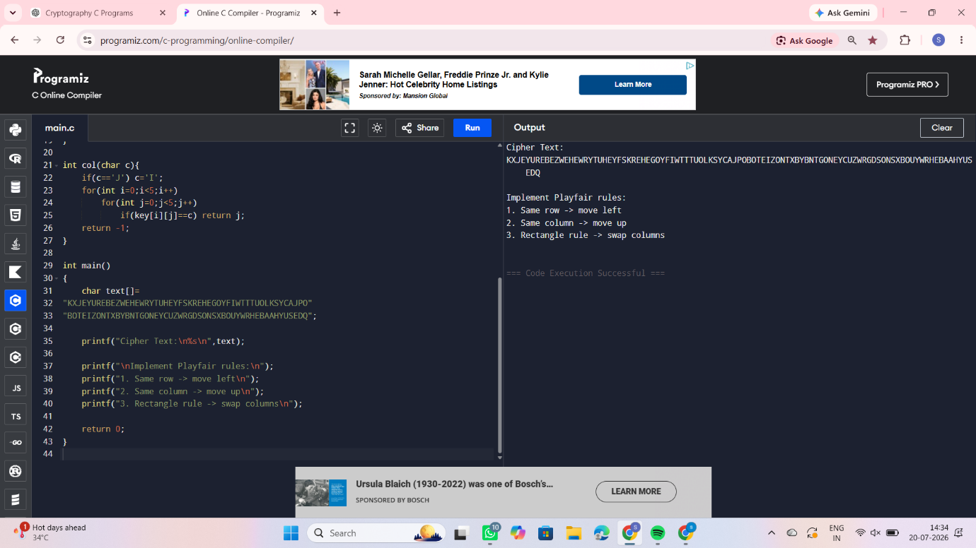

10.#include<stdio.h>
#include<ctype.h>
#include<string.h>

char key[5][5]={
{'M','F','H','I','K'},
{'U','N','O','P','Q'},
{'Z','V','W','X','Y'},
{'E','L','A','R','G'},
{'D','S','T','B','C'}
};

int row(char c){
if(c=='J') c='I';
for(int i=0;i<5;i++)
for(int j=0;j<5;j++)
if(key[i][j]==c) return i;
return -1;
}

int col(char c){
if(c=='J') c='I';
for(int i=0;i<5;i++)
for(int j=0;j<5;j++)
if(key[i][j]==c) return j;
return -1;
}
int main()
{
printf("Plain Text:\n");
printf("MUST SEE YOU OVER CADOGAN WEST COMING AT ONCE\n");
printf("\nEncrypt using Playfair rules:\n");
printf("1. Same row -> move right\n");
printf("2. Same column -> move down\n");
printf("3. Rectangle -> exchange columns\n");
return 0;
}